**Electrochemistry Lab Activity**

**Part 1. Building Galvanic Cells**

1. Obtain a piece of filter paper. Using a pair of scissors, cut a wedge as shown in Figure 1. Place the filter paper on top of a Petri dish or glass plate.
2. Obtain one piece of zinc and once piece of copper metal. Sand each piece of metal with sandpaper so there is a shiny, clean surface on both sides.
3. Place 3 drops of the appropriate metal ion salt solutions on the filter paper, as shown in Figure 1. Then place the corresponding pieces of metal on the wet spots. The top side of the metal should be kept dry.
4. Add several drops of 1 M NaNO3 between each of the metal ion salt solutions - this is the salt bridge. Be sure there is a continuous trail of NaNO3 between the two metal ion salt solutions.
5. Determine the potential of the cell by connecting the black lead to zinc and the red lead to copper, with the voltmeter set to the DC volt setting.
6. Make a detailed entry in your notebook about this experiment. This should include, at a minimum, a sketch like Figure 1 with everything properly labeled, how the leads of the voltmeter are attached, and voltmeter reading; the side of your cell you believe is the cathode and the side that is the anode; and a paragraph describing key procedural details. Show your notebook to your instructor or CA before proceeding.
7. Repeat steps 1 – 6, this time with your unknown metal. Once you record the voltage of your cell, use the table of standard electric potentials to identify your unknown.
8. Repeat steps 1 – 6, this time with the two different concentrations of the same metal ion salt. Record the voltage of the cell, and determine which solution has the higher concentration of cations. Then use <https://web.mst.edu/~gbert/Electro/Electrochem.html> to quantify the ratio of cation concentration (cathode/anode).

**Part 2. Electrolysis of water**

Wire up the electrolysis apparatus to the battery, study it for a minute or two, and make an entry about it in your notebook. This entry should include a sketch showing which battery terminal (+ or -) seems to be generating more gas.

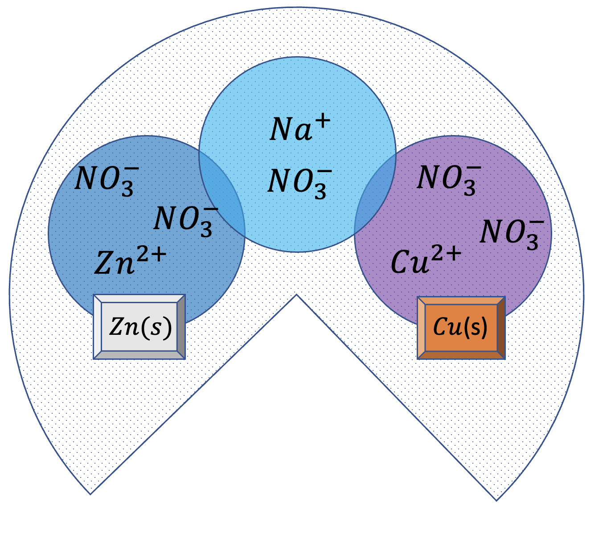

**Figure 1.** A filter paper galvanic cell.